Part 4. Writing an e-mail of reply

You are Patrick / Patricia Li, the secretary of the English Club in your school. The Chairman of the club, Leo Ma, sent you this e-mail just now to give you information and instruction for drafting a poster for the Singing Contest at Christmas at your school. Based on the information, write a mail of reply with a poster attached for the singing contest.

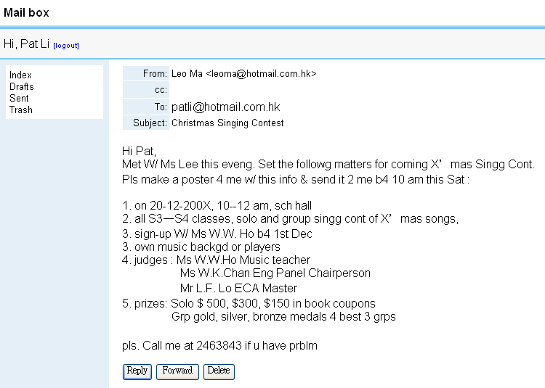
- Many words in the e-mail are written in abbreviated (shortened) forms. Replace them with complete forms of these words in the following mail from Leo Ma.
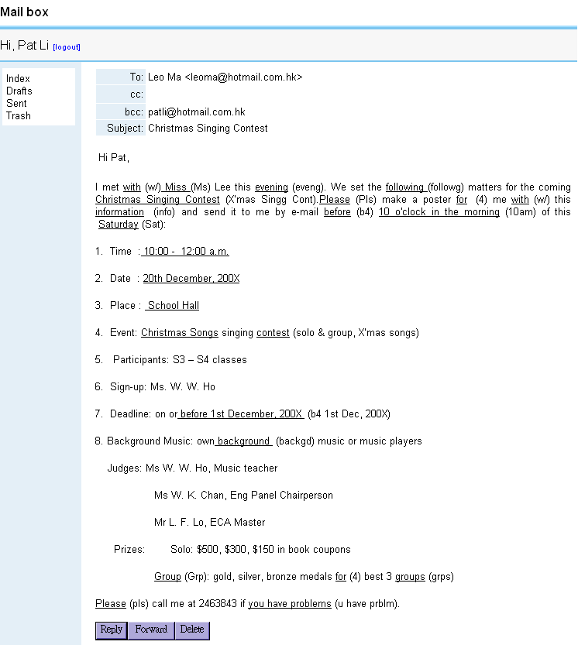
- Many words in the e-mail are written in abbreviated (shortened) forms. Replace them with complete forms of these words in the following mail from Leo Ma.
Suggested answer

- Reply e-mail by Pat
Send a reply to Leo Ma to tell him that you have received his e-mail about the Christmas Singing Contest and inform him your drafting a poster for the contest and attaching it in the e-mail for his comments by filling in the missing information in the blanks.

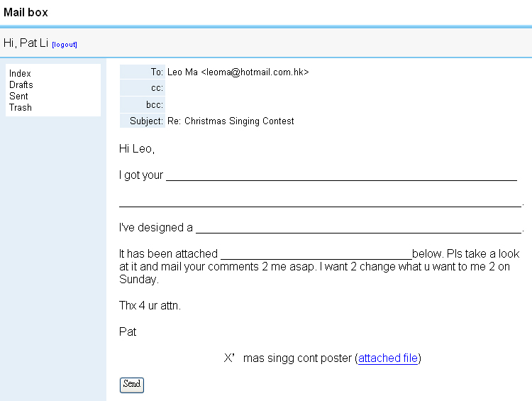
- Reply e-mail by Pat
Send a reply to Leo Ma to tell him that you have received his e-mail about the Christmas Singing Contest and inform him your drafting a poster for the contest and attaching it in the e-mail for his comments by filling in the missing information in the blanks.
Suggested reply
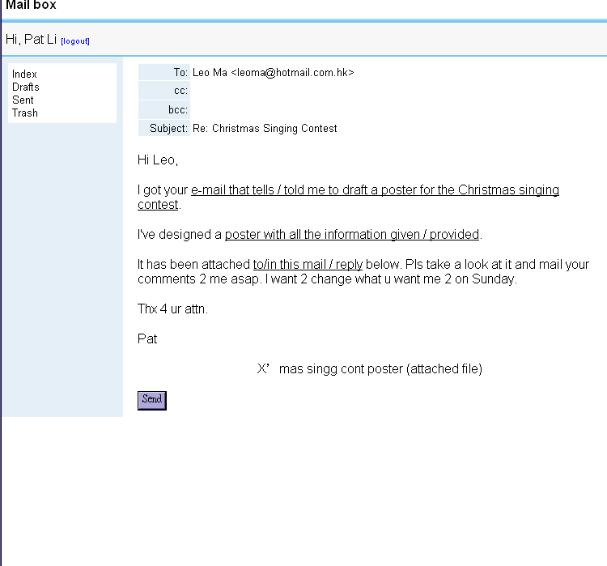
Attached poster designed by Pat in the e-mailed reply
(Fill in with details)


Date :  Time :  Venue : | _____________, 200X  10:00 – 12 00 a.m.  School ____________
Classes to join: | _________________
Events : | Solo and _________ __________ songs
Background Music : | Playing music on hi-fi /  Real person playing
Sign-up : | ________ W.W. Ho
Deadline : | On or _______________________
Judges : | Ms W.W.Ho Music teacher  Ms W.K.Chan Eng Panel Chairperson  Mr L.F. Lo ECA Master
Prizes : | Solo  Champion $ 500 book coupon  __________ -Runner-up $ 300 book coupon  __________ -Runner-up $ 150 book coupon  G________  Champion gold ________  ____________________ silver ________  ____________________ bronze ________

- Attached poster designed by Pat in the e-mailed reply
suggested details in the poster

Date :  Time :  Venue : | 20 December, 200X / 20-12-200X  10:00 – 12 00 a.m.  School Hall
Classes to Join : | S3-4 / Sec3-4
Events : | Solo and group Christmas songs
Background Music : | Playing music on hi-fi /  Real person playing
Sign-up : | Miss W.W. Ho
Deadline : | On or before 1 Dec, 200X / 1-12-200X
Judges : | Ms W.W.Ho Music teacher  Ms W.K.Chan Eng Panel Chairperson  Mr L.F. Lo ECA Master
Prizes : | Solo  Champion $ 500 book coupon  First -Runner-up $ 300 book coupon  Second -Runner-up $ 150 book coupon  Group  Champion gold medal  First-Runner-up silver medal  Second-Runner-up bronze medal

